# V2X HUB Vehicles’ Turning Percentage Logic

This document outlines the estimation of turning percentage of vehicles for V2X Hub. In the connected environment, vehicle turning percentage could be identified with vehicle trajectories and can be identified by counting the discharged connected vehicles turning at each direction during the last time interval.

## Requirements and Assumptions

* Connected vehicles are equipped with OBUs.
* Connected vehicles should be able to frequently send BSMs to V2X Hub through an RSU when entered to a certain vicinity of the RSU.
* All directions have an equal percentage of connected vehicles.

## Inputs to the Vehicles’ Turning Percentage Estimation Algorithm

* BSM
  + Vehicle location
* MAP
  + Roadway geometry
* Parameters
  + RSU detection space range
  + Time interval

## Steps to the Vehicles’ Turning Percentage Estimation

As the inputs are continuously fed into V2X Hub, the turning percentage of vehicles are estimated at every predetermined time interval. The estimation algorithm is divided into two sections: event-based and time-based. The steps in the event-based section are performed as a connected vehicle enters or exits the RSU range or discharges from the intersection. The time-based section of the algorithm is iterated at every predetermined time interval. The algorithm is applied to each intersection direction separately. Let $t$ and $Δt$ define the current time and time interval duration, respectively. Figure 1 shows the algorithm flowchart. The algorithm steps is as follows.

Event-based steps:

1. As a connected vehicle enters or exits the RSU range, update the list of connected vehicles.
2. As a connected vehicle discharges from the intersection (crosses the intersection stop bar), update the counts vector. The counts vector has three elements and indicates the number of connected vehicles that are discharged from the intersection and proceeded to the right, through, or left directions. As a connected vehicle crosses the intersection stop bar and its movement direction is realized, the corresponding element of the counts vector is added by one. Let $C$ denote the counts vector and $C_{m}$ the $m$ th element of $C$, where $m=1, 2,$ and $3$ represent the right, through, and left movements, respectively.

Time-based steps:

1. Calculate the turning percentages. Let $TP_{m}$ denote the turning percentage of movement $m$, $∀m=1,2,3$, which is formulated as
$${TP}_{m}=\frac{C_{m}}{\sum_{m}{C_{m}}},$$

2. Set $C_{m}≔0,m=1,2,3$.

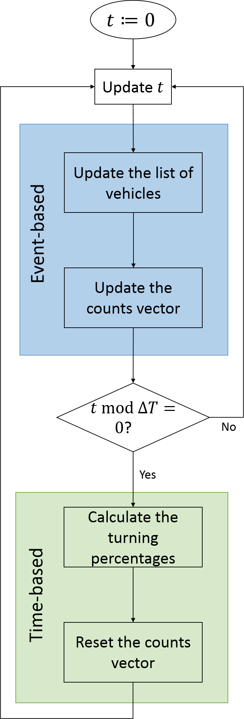

Figure 1 Algorithm flowchart (source: FHWA).